**DAYANANDA SAGAR COLLEGE OF ENGINEERING**

*(An Autonomous Institute Affiliated to VTU, Belagavi)*

Shavige Malleshwara Hills, Kumaraswamy Layout, Bengaluru-560078

**Department of Electronics and Communication Engineering**



Title of the Topic

**AAT**

for

**Fundamentals of Signals and Systems**

**(22EC34)**

Submitted by

**Batch No-X**

|  |  |  |  |  |  |  |  |
| --- | --- | --- | --- | --- | --- | --- | --- |
| **Sl No** | **USN** | **Name** | **Marks** | | | |  |
| **MATLAB courses**  **(2)** | **Simulation (3)** | **Report/PPT**  **(3)** | **Presentation/**  **Q/A**  **(2)** | **Total**  **(10)** |
| 1 |  |  |  |  |  |  |  |
| 2 |  |  |  |  |  |  |  |
| 3 |  |  |  |  |  |  |  |
| 4 |  |  |  |  |  |  |  |

Submitted to:

**Prof. Kavita Guddad**

**FSAS Teacher**

**Academic Year**

**Oct-23-Jan-24**

**Contents**

**1. Objective/Aim**

**2. Detailed Explanation of Topic**

**3. Manual Calculation**

**4. MATLAB Code**

**5. Results**

**6. Reflection note (Technical and non-technical skills learnt from**

**AAT)**

**7. MATLAB & Simulink onramp course certificates**

**8. References**

**Objective/Aim:-** Design and Simulation of Op Amp as an integrator in MATLAB.

**Detailed Explanation of Topic:-**

**1. Introduction to Op Amp as an Integrator:**

**-** An operational amplifier (Op Amp) is a versatile analog component commonly used in electronic circuits.

- When configured as an integrator, an Op Amp can perform the mathematical operation of integration on the input signal.

**2. Basic Circuit Configuration:**

**-** The integrator circuit consists of an Op Amp, a feedback resistor (Rf), and a capacitor (C).

- The input signal is applied to the inverting terminal of the Op Amp, and the output is taken from the junction of the capacitor and feedback resistor.

**3. Transfer Function:**

The transfer function of the integrator circuit is given by *H*(*s*)=−1/*Rf*​*C*⋅*s*1​, where *s* is the complex frequency variable.

**4. Frequency Response:**

- The integrator circuit exhibits a -20 dB/decade roll-off in its frequency response.

- As the frequency of the input signal decreases, the gain of the circuit increases.

**5. Input and Output Waveforms:**

- Simulate the circuit using simulation software such as SPICE or LTspice to observe the input and output waveforms.

- Input a square wave or a triangular wave to observe the integration effect.

**6. Component Selection:**

**-** Choose appropriate values for the feedback resistor (Rf) and capacitor (C) based on the desired integration time constant.

- The time constant (*τ*) is given by *τ*=*Rf*​⋅*C*.

**7. Unity Gain Frequency:**

**-** The unity gain frequency (funity) is the frequency at which the magnitude of the transfer function becomes 1.

*f*unity​=1/2*πRf*​*C*1​

**8. Slew Rate Considerations:**

- Ensure that the Op Amp chosen has a slew rate sufficient to handle the rate of change of the integrated signal.

**9. Limitations:**

**-** Integrators may exhibit drift and offset errors over time.

- Careful consideration of these limitations is crucial for precision applications.

**10. Practical Considerations:**

**-** Practical integrator circuits may include additional components such as input resistors, capacitors for filtering, and protection circuits.

- Consider noise sources and ensure adequate bandwidth for the desired signal frequency.

**By addressing these points, you can design and simulate an Op Amp as an integrator, understanding its theoretical foundation, practical considerations, and limitations.**

**Manual Calculation:-**

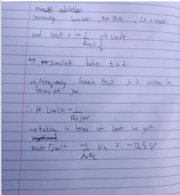

**SIMULATION**

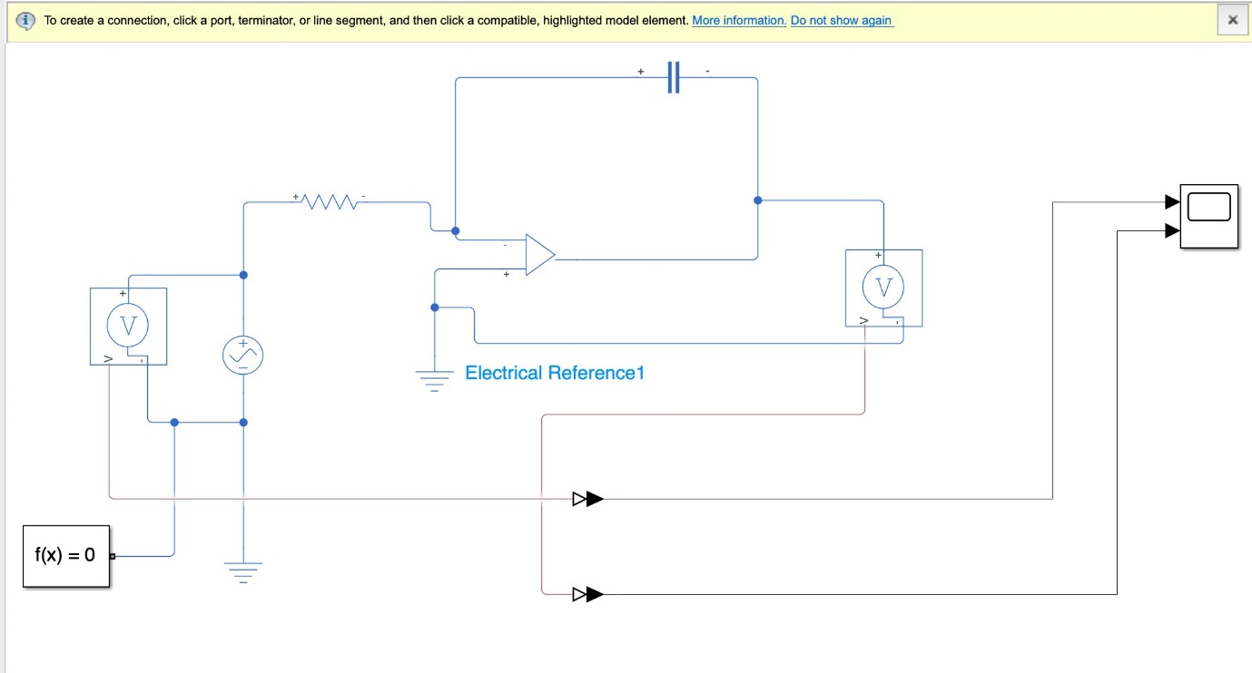**Results:-**

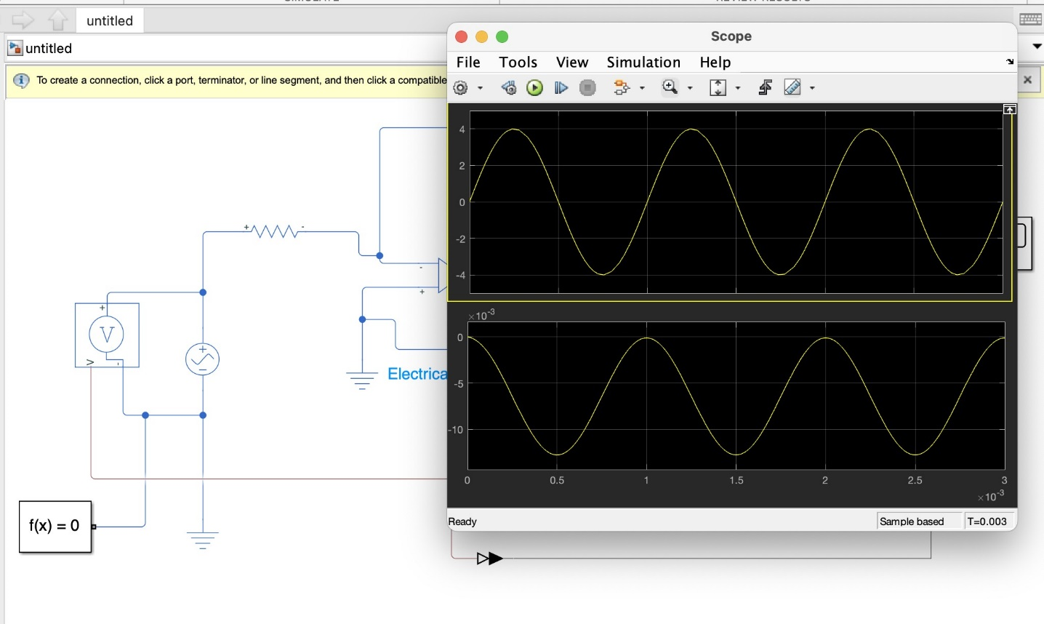

**Reflection note (Technical and non-technical skills learnt from AAT)**

Designing and simulating an op-amp as an integrator in MATLAB helped us understand the basic and fundamental concepts of op-amp circuits, mainly its integrator function. Building a virtual model in MATLAB gave us insight into its practical applications. This experience emphasized the crucial role of simulation tools in designing various circuits in the field of electronics.

**MATLAB & Simulink onramp course certificates:-**

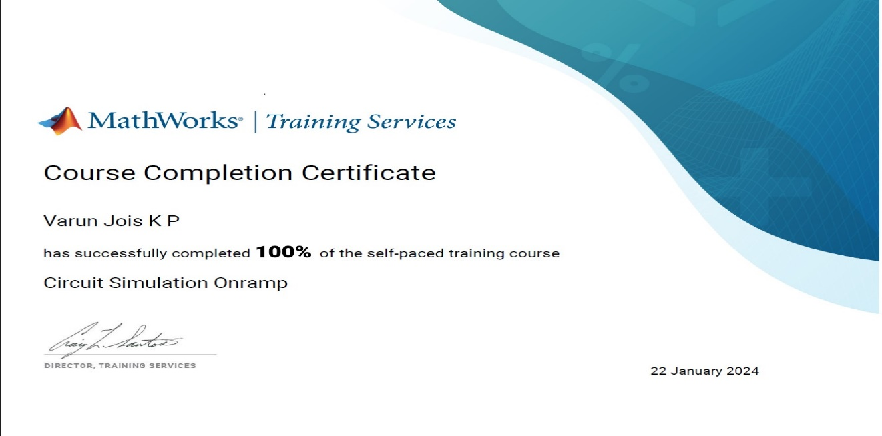

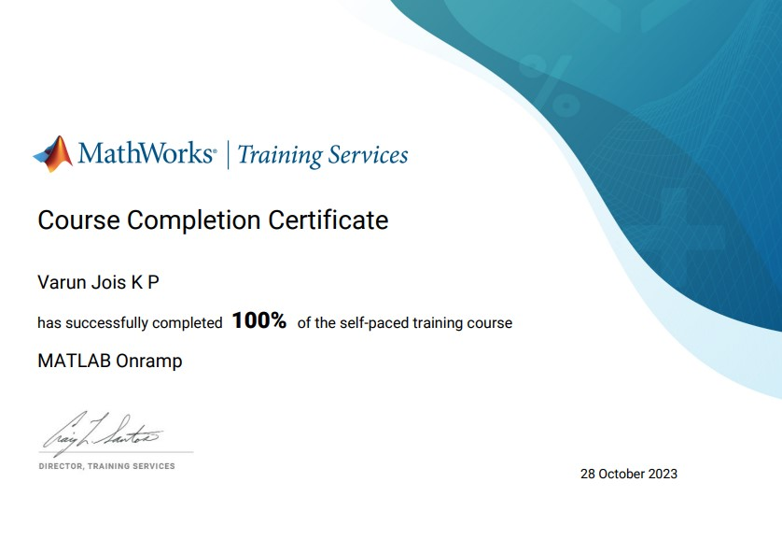

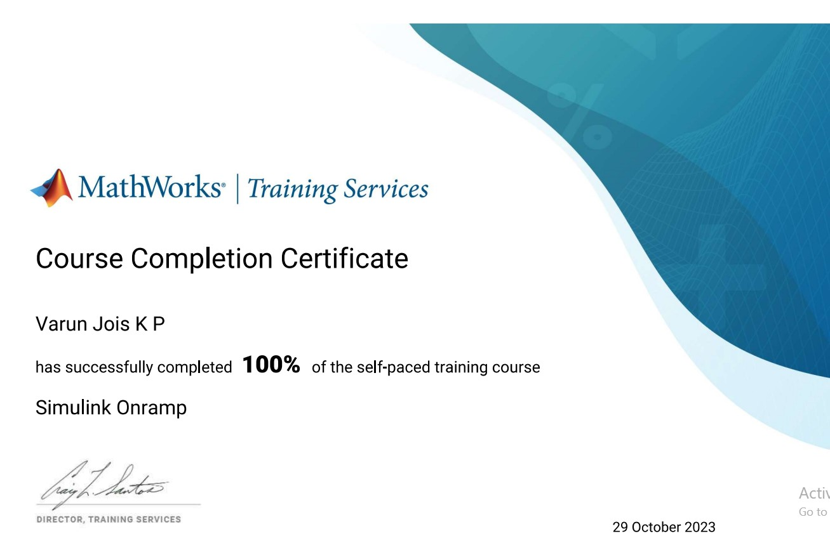

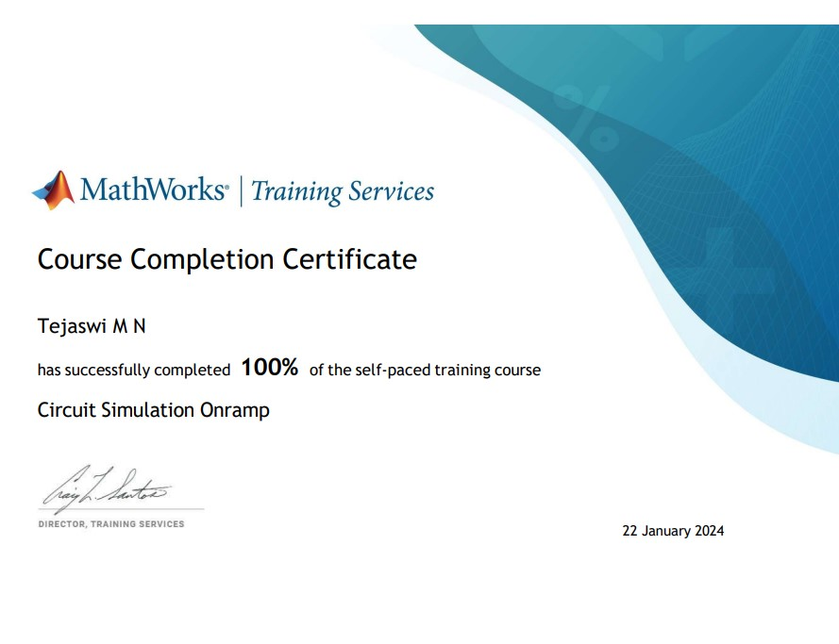



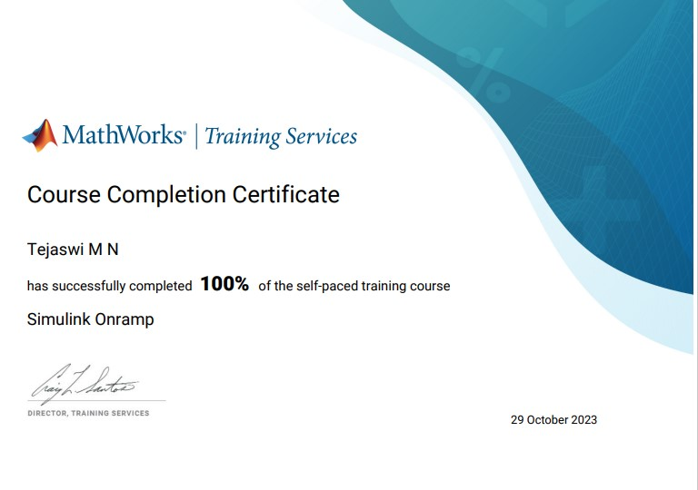

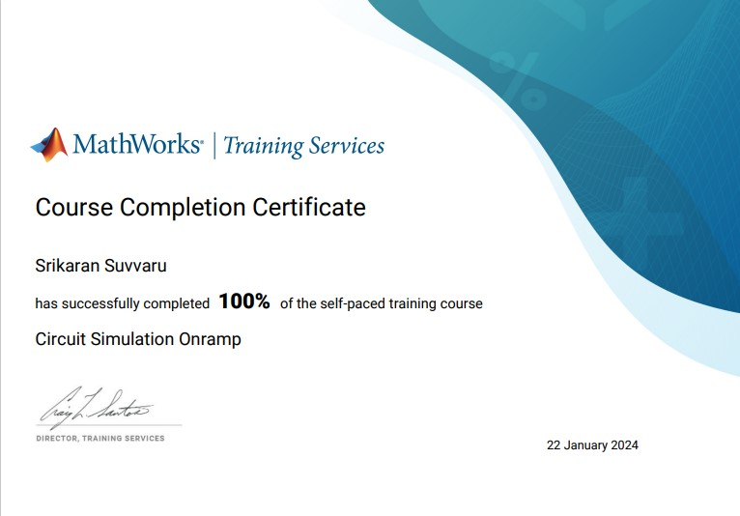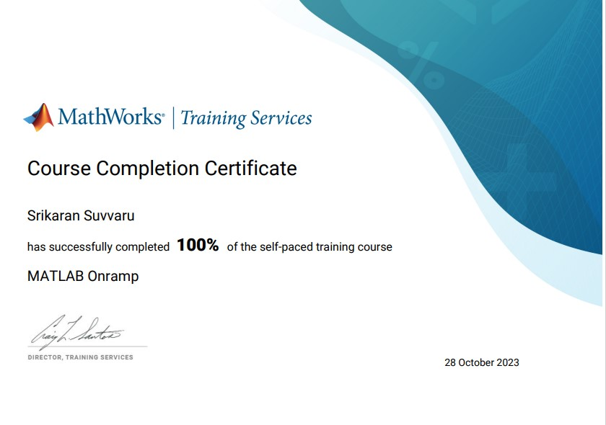



**References:-**